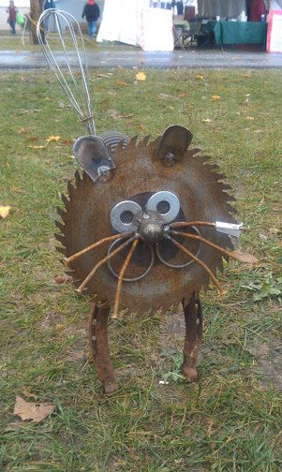
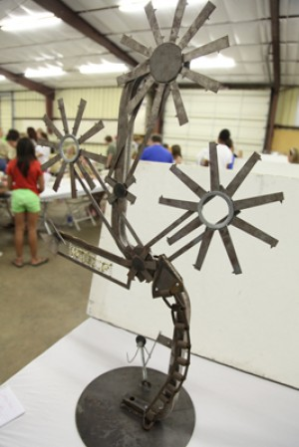
Bucket of Junk Contest
Jefferson Township Fair
August 10th-14th 2021
1st Place $50.00

Anyone over 18 years old is eligible to enter this contest. We will provide a five-gallon bucket of unique pieces, probably otherwise known as “junk”. All the buckets will include the same number of items and be as close to identical as possible. There will be a $10.00 entry fee per bucket/creation.
You can clean, sand, weld, blue, cut, bolt, fasten, bend, shape, paint or finish the items that were provided. BUT no pieces can be added. Create whatever you want with the contents of your bucket. The goal is to use all the items in the bucket.
The five-gallon buckets will be available August 2nd – August 4th. They can be picked up at Watson’s Inc. from 8am – 4pm. There will be a limited number of buckets available, so please call early. First come first served. Any questions or concerns please contact Eric Watson @ 724-301-2194
Entry day will be Sunday August 8th from 2 - 4pm or Monday August 9th from 2 - 6pm at the exhibit building. We ask that you please bring back the bucket so we can continue this contest next year. When you leave you creation at the exhibit building, you will be asked to name it.
Rules
1. All pieces are to be used in the finished creation.
2. You can cut, weld or form any piece. If you cut a piece BOTH pieces MUST be used.
3. ALL creations will be judged on creativity, workmanship and inclusion of ALL pieces of the bucket.
4. A count of the junk pieces will be done to aid in the judging. ALL pieces must be used.

*Creations can be picked up to take home after the fair on Sunday August 15th 2-4pm
_____________________________________________________________________
Detach here when you enter your creation

Bucket Number_________________________________________________________________

Name of Creation_______________________________________________________________

